12.1.1 Editors - Compositor - Header - Tools and Options
Options 1
Use Nodes 1
Pin (pin icon) 1
Parent Node Tree 1
Backdrop 1
Display channels 1
Snap 2

Options

At the right side of the header you will see the options.

Use Nodes
The Use Nodes setting is mostly a legacy setting and should always be checked for materials.

Pin (pin icon)
The pin button will keep the current material selection fixed. When a material is pinned, it will remain visible in the shader editor even when another object or material is selected elsewhere.

Parent Node Tree
Grouping nodes can simplify a node tree by allowing instancing and hiding parts of the tree. Both material and composite nodes can be grouped. This button becomes active when you work with such grouped nodes, and you are in a child group. it allows you to switch to the parent group.

Backdrop
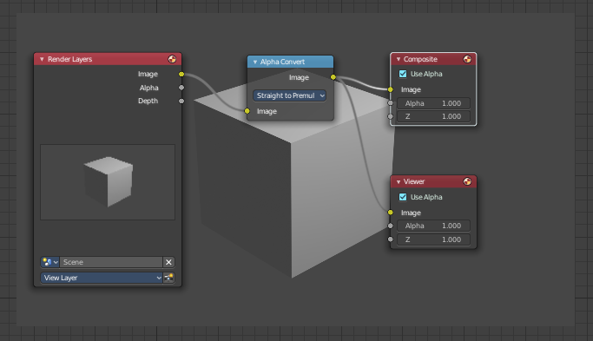
By adding a viewer node you can display the compositing result as a background in the viewport. Here you can activate it, and adjust the look.

Display channels
What channels to display in the backdrop.

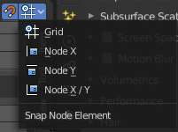
Snap
Activates snapping. When the tool is activated, then you will also reveal the snap settings where you can choose different snap methods.

